Computer Language Coding Concepts

Joint Display of Access Connectors and Object Relations
When you see a parameter as a relation between a command and an object, it used to be a paradox, that the parameter can always point to an object on the outside, even though the parameter passing said, that you can only point to the parameter.

This problem was taken away by completely separating the object relations on one hand, and on the other hand access controlling the system aspects of the parameter. In a diagram you will also see those two things separately displayed.

The relational position of the object and the way you can access it are separately expressed in the diagram, and not by means of the same lines.

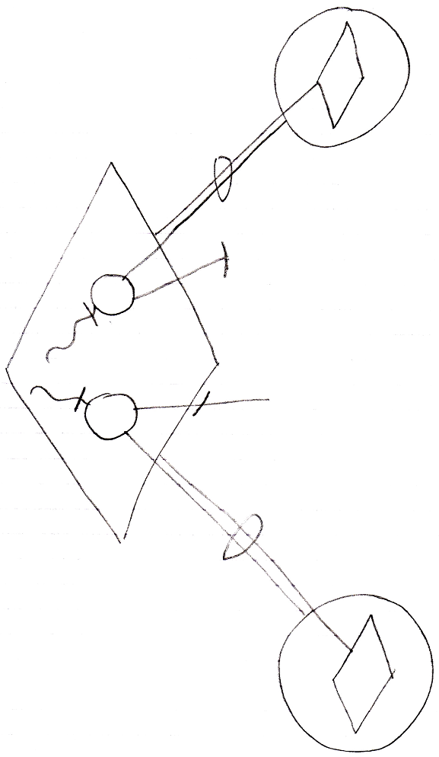

The open-ended lines of the circles inside the diamond are the parameters’ access connectors, that define how the parameter is or can be used. You can define a new relation to the command by tying an object to an access connector of a prameter. The access connector will not be taken in use, because after you’ve used it to define a relation to the command, the access connector is still there, open for usage.

Author & Copyright: Jan-Joost van Zon Date: September 21, 2008 – September 21, 2008 Location: Oosterhout, The Netherlands Status: Finished

